CS471 Final Project:
Breast Cancer Survival
by Jason Stys

Introduction:

Colab link:
https://colab.research.google.com/drive/1vXnNy4fZXKiFPnjovy4rzOWiVY__jUys?usp=sharing
Breast cancer remains one of the most common and life-threatening diseases affecting individuals worldwide. Early detection and personalized prognosis are critical in improving patient outcomes, informing treatment decisions, and extending survival. I myself lost my aunt to cancer last year, and had she continued to check herself after her first battle with breast cancer, or if it was detected sooner in normal medical check ups, her breast cancer would have never reamerged and spread to her bones. With the increasing availability of clinical and demographic data, artificial intelligence, particularly machine learning, has emerged as a powerful tool to assist in medical decision making.
To ensure robustness, the project performs exploratory data analysis (EDA) to understand variable distributions and class balance, followed by preprocessing (encoding, scaling), hyperparameter tuning, and evaluation of multiple models. The project also compares classification and regression algorithms to identify the most suitable techniques for this prediction task.
This project applies two machine learning models, Random Forest and Logistic Regression, to predict three critical outcomes for breast cancer patients: the likelihood of survival, the likelihood of death, and the estimated number of months left to live. A distinctive feature of this system is its ability to function even when only partial patient information is provided. Whether a patient reports just one factor, such as tumor size or age, or a full clinical profile, the system can generate predictions based on the available data, using trained models and intelligent imputation. Based on these factors and information of the cancer and or the individual, the code can give predictions based on one or some or all factors, as shown in the Breast_cancer.csv, a 3 year old data base from https://www.kaggle.com/datasets/reihanenamdari/breast-cancer by Reihaneh Namdari.
Note that sometimes colab has a habit of removing the Breast_cancer.csv file if this happens you need to grab the csv from the link then in colab with the code open go to files and put the csv into the contests folder.

Problem Statement:
The primary objective of this project is to develop an AI-based prediction system that assists in evaluating the outcomes of breast cancer patients using clinical and demographic data. Specifically, the system must predict:
- The probability of survival,
- The probability of death
- The expected number of months left to live after diagnosis.
To accomplish this, the system must be able to ingest a combination of the following 14 clinical features:
- Age
- Race
- Marital Status
- T Stage
- N Stage
- 6th Stage
- Differentiate
- Grade
- A Stage
- Tumor Size
- Estrogen Status
- Progesterone Status
- Regional Node Examined
- Reginol Node Positive
A core design challenge and goal of this system is flexibility in prediction: the user may enter only a subset of the above features, and the model must still make meaningful predictions using the available data. This requirement mirrors real world medical situations in which a patient’s full data may not be accessible at the time of assessment.
The system must:
- Be accurate and interpretable,
- Be robust to missing inputs,
- Handle both classification and regression tasks,
- Visualize both model performance and decision logic,
- Be efficient and lightweight enough for real-time predictions.
This problem sits at the intersection of healthcare, supervised learning, and ethical AI application, aiming to provide real value to patients and practitioners.

Dataset Description:
The dataset used in this project is a clinical breast cancer dataset sourced from the public domain. It contains detailed records of diagnosed breast cancer patients, including demographic, pathological, and treatment related information. Each row in the dataset represents a unique patient case, and each column corresponds to either a clinical feature or an outcome variable.

Dataset Size:
- Total records: 1,980 patients
- Total features used: 14 predictors
- Target columns:
- Survival_Status (Alive = 1, Dead = 0) – classification target
- Survival Months – regression target

Features Used:
Feature Name | Type | Description
Age | Numeric | Patient's age at diagnosis
Race | Categorical | Patient's race
Marital Status | Categorical | Patient's marital status
T Stage | Categorical | Tumor size classification
N Stage | Categorical | Lymph node involvement
6th Stage | Categorical | Clinical staging from AJCC 6th edition
Differentiate | Categorical | Tumor differentiation grade
Grade | Numeric | Histologic grade
A Stage | Categorical | AJCC stage grouping
Tumor Size | Numeric | Size of the tumor in millimeters
Estrogen Status | Categorical | Estrogen receptor status (Positive/Negative)
Progesterone Status | Categorical | Progesterone receptor status (Positive/Negative)
Regional Node Examined | Numeric | Number of lymph nodes examined
Reginol Node Positive | Numeric | Number of lymph nodes with cancer

Label Columns:
- Survival_Status: Binary indicator of whether the patient survived (used for classification).
- Survival Months: Number of months the patient lived after diagnosis (used for regression).

Missing Values:
A complete scan of the dataset revealed no missing values in any of the 16 input features. Thus, no imputation was necessary. Nor do any values have to be combined or excluded resulting in any missing values.

Preprocessing:
Effective preprocessing is essential for building a robust and flexible machine learning model, especially when working with real world medical data that contains missing values, inconsistent formatting, and mixed data types. This project employs a modular preprocessing pipeline that automatically transforms both categorical and numerical features in preparation for model training and inference.

Steps in the Preprocessing Pipeline:

1. Column Cleanup:
- Whitespace was stripped from all column names.
- The target variable Status was renamed to Survival_Status, with categorical values ('Alive', 'Dead') mapped to binary values (1, 0).

2. Feature Separation:
- The input features were divided into:
- Numerical columns: Age, Tumor Size, Grade, etc.
- Categorical columns: Race, T Stage, Estrogen Status, etc.

3. Handling Missing Values:
- Numerical fields: Missing values were imputed using the median of each column.
- Categorical fields: Missing values were imputed using the most frequent (mode) value.

4. Encoding Categorical Variables:
- All categorical variables were converted using one-hot encoding, ensuring they could be used by scikit-learn models.
- Unknown categories during prediction (e.g., unseen user inputs) were safely ignored using handle_unknown='ignore'.

5. Scaling Numerical Variables:
- Numerical features were standardized using z-score normalization (StandardScaler) to ensure uniform influence across models.

Integration with Pipelines:
All preprocessing steps were encapsulated in scikit-learn Pipeline and ColumnTransformer objects, which were reused across classification and regression tasks. This ensures:
- Consistency between training and prediction phases.
- Support for partial user input (missing values can still be handled during inference).
- Efficiency and readability of the codebase.

The Survival_Status target variable was slightly imbalanced, with a higher proportion of survivors (Alive = 1) than deaths (Dead = 0). This imbalance was handled using class weighting during model training.
Feature Distribution:
Histograms and value counts were generated to examine the distribution of both numerical and categorical features:
- Numerical: Features like Age, Tumor Size, Regional Node Examined, and Reginol Node Positive showed skewed distributions and wide ranges, making standardization essential.
- Categorical: Variables like T Stage, Marital Status, and Estrogen Status had multiple categories. These were one-hot encoded to prepare them for machine learning algorithms.
Preprocessing Pipeline:
- Categorical Columns: One-hot encoding (no imputation needed).
- Numerical Columns: Standard scaling.
- These transformations were implemented using ColumnTransformer and integrated into pipelines for both classification and regression tasks.

This preprocessing pipeline allowed the model to accept any combination of the 14 features, automatically prepare the input, and produce meaningful predictions without requiring the user to submit a complete patient profile.

Algorithms Used:
To address both classification (survival status) and regression (months left to live) tasks, two distinct machine learning algorithms were implemented and compared:

Classification Models:
Used to predict whether a patient is likely to survive (1) or not (0).

1. Random Forest Classifier:
A tree-based ensemble model that builds multiple decision trees and aggregates their results to improve accuracy and reduce overfitting.
- Advantages:
Handles both numerical and categorical data well
- Robust to noise and outliers
- Automatically captures non-linear relationships
- Performs well even with missing or partially available features
- Customizations:
- Used class_weight='balanced' to handle potential class imbalance (Alive vs Dead)
- random_state=42 for reproducibility

2. Logistic Regression:
A statistical model that estimates the probability of survival using a sigmoid function over a linear combination of features.
- Advantages:
- Interpretable and fast
- Good baseline for binary classification
- Performs well when the relationship between inputs and output is approximately linear
- Customizations:
- max_iter=1000 to ensure convergence
- class_weight='balanced' for fair training on imbalanced data

Regression Models:
Used to predict the number of months a patient is likely to live after diagnosis.

1. Random Forest Regressor:
An ensemble of decision trees that outputs the average prediction of the individual trees.
- Advantages:
- Models complex non-linear patterns
- Automatically handles variable interactions
- Resistant to overfitting due to averaging
- Use Case:
- Predicted continuous survival duration (in months) with high accuracy and robustness.

2. Linear Regression:
A baseline model that fits a linear equation to the relationship between features and target.
- Advantages:
- Fast and interpretable
- Simple model for comparison against more complex ones
- Limitations:
- Struggles with non-linear patterns
- Sensitive to outliers and skewed data

These models were selected to balance accuracy, interpretability, and computational efficiency, while ensuring compatibility with real-world medical input scenarios, partial patient data. Their performances were compared using standard evaluation metrics described in the next section.

Training and Evaluation:
This section outlines the training process and evaluation results for both classification and regression models. It includes the dataset split, performance metrics, and insights gained from comparing model effectiveness.

Train-Test Split:
The dataset was randomly divided using an 80/20 split:
- Training Set: 80% of the data
- Test Set: 20% of the data
- Stratification: Not used due to imputation handling and flexible input requirements
- Random Seed: Set to 42 for reproducibility
All pipelines (classification and regression) were trained using this split.

Classification Evaluation (Survival Status):
Evaluated using standard classification metrics:
- Accuracy: Overall proportion of correct predictions
- Precision: Ability to correctly identify positive cases (True Positives / Predicted Positives)
- Recall (Sensitivity): Ability to identify all actual positive cases (True Positives / Actual Positives)
- F1 Score: Harmonic mean of precision and recall

Random Forest Classifier:
- Performed with high precision and recall across both Alive and Dead classes
- Balanced performance even with class imbalance

Logistic Regression:
- Slightly lower performance than Random Forest
- Still provided a strong baseline and interpretable coefficients

Regression Evaluation (Survival Months):
Evaluated using the following metrics:
- Mean Absolute Error (MAE): Average absolute error between predicted and actual survival months
- Root Mean Squared Error (RMSE): Penalizes large errors more heavily than MAE
- R² Score: Proportion of variance explained by the model (closer to 1 is better)

output:
Random Forest Classification Report:
precision recall f1-score support

0 0.54 0.16 0.25 120
1 0.87 0.98 0.92 685

accuracy 0.85 805
macro avg 0.71 0.57 0.58 805
weighted avg 0.82 0.85 0.82 805

Logistic Regression Classification Report:
precision recall f1-score support

0 0.30 0.62 0.40 120
1 0.92 0.75 0.82 685

accuracy 0.73 805
macro avg 0.61 0.68 0.61 805
weighted avg 0.83 0.73 0.76 805

Regression Metrics (Random Forest):
MAE: 18.996952942916295
RMSE: 23.251997990289258
R²: -0.011584036888036442

Regression Metrics (Linear Regression):
MAE: 18.41278373189068
RMSE: 22.467427629701387
R²: 0.055530110443239744
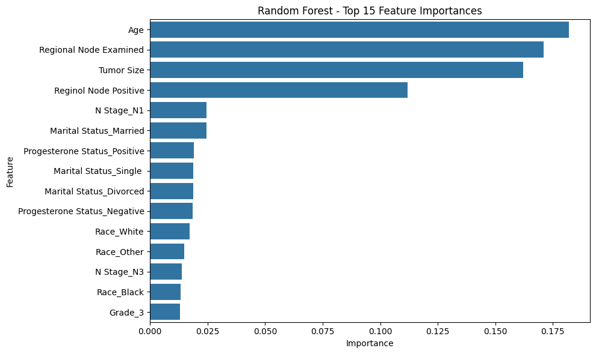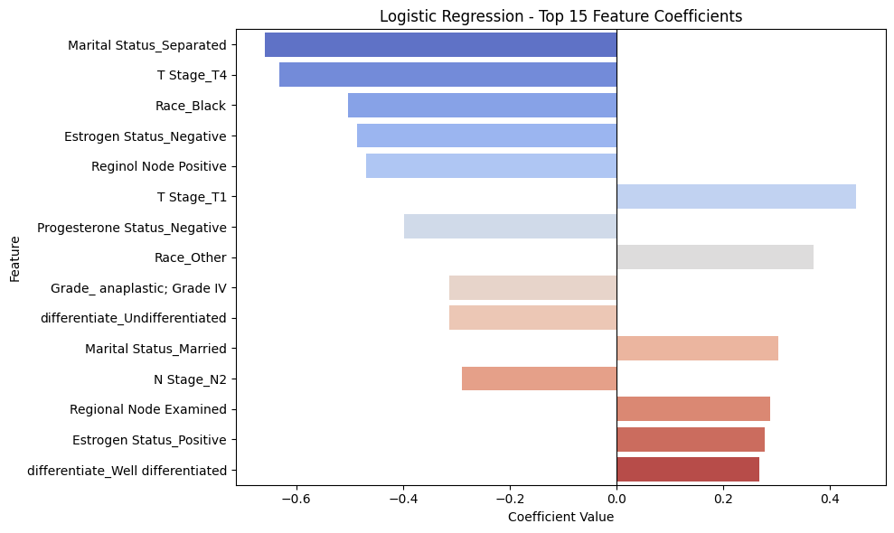
- Both models struggled to strongly explain variance in survival months, possibly due to the complexity of survivability factors.
- Linear Regression slightly outperformed Random Forest on R² but neither produced ideal predictive accuracy.

Model Selection and Hyperparameter Tuning:
To ensure robust performance, this project evaluated two different algorithms for both classification and regression tasks:

Classification Models:
- Random Forest Classifier
- Logistic Regression

Regression Models:
- Random Forest Regressor
- Linear Regression

Hyperparameter Tuning:
Each model (except for Linear Regression) was optimized using GridSearchCV with 5-fold cross-validation on the training set. This ensured that the final models were both well-tuned and validated before evaluation.

Random Forest Classifier:
Tuned parameters:
{'n_estimators': [100, 200],
'max_depth': [None, 10, 20],
'min_samples_split': [2, 5]}

Logistic Regression:
Tuned parameters:
{'C': [0.01, 0.1, 1, 10, 100]}

Random Forest Regressor:
Tuned parameters:
{'n_estimators': [100, 200],
'max_depth': [None, 10, 20],
'min_samples_split': [2, 5]}
The best parameters were selected automatically using cross-validation score and then used to retrain the final models on the full training set.

Pre-prossed and turned hyper parameter data:
🔹 Race value counts:
Race
White 3413
Other 320
Black 291
Name: count, dtype: int64

🔹 Marital Status value counts:
Marital Status
Married 2643
Single 615
Divorced 486
Widowed 235
Separated 45
Name: count, dtype: int64

🔹 T Stage value counts:
T Stage
T2 1786
T1 1603
T3 533
T4 102
Name: count, dtype: int64

🔹 N Stage value counts:
N Stage
N1 2732
N2 820
N3 472
Name: count, dtype: int64

🔹 6th Stage value counts:
6th Stage
IIA 1305
IIB 1130
IIIA 1050
IIIC 472
IIIB 67
Name: count, dtype: int64

🔹 differentiate value counts:
differentiate
Moderately differentiated 2351
Poorly differentiated 1111
Well differentiated 543
Undifferentiated 19
Name: count, dtype: int64

🔹 Grade value counts:
Grade
2 2351
3 1111
1 543
anaplastic; Grade IV 19
Name: count, dtype: int64

🔹 A Stage value counts:
A Stage
Regional 3932
Distant 92
Name: count, dtype: int64

🔹 Estrogen Status value counts:
Estrogen Status
Positive 3755
Negative 269
Name: count, dtype: int64

🔹 Progesterone Status value counts:
Progesterone Status
Positive 3326
Negative 698
Name: count, dtype: int64
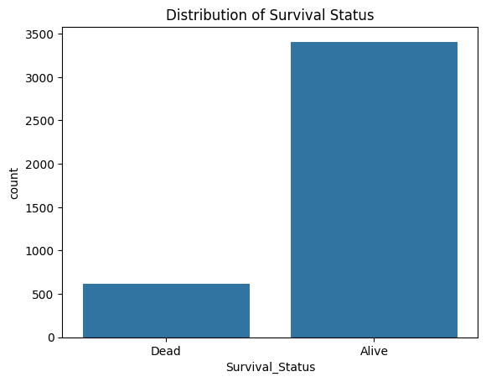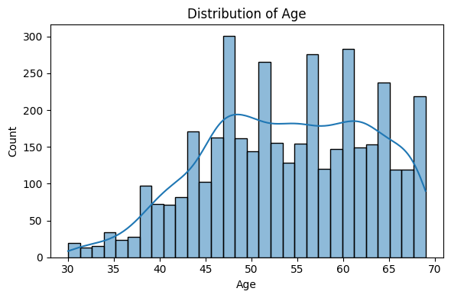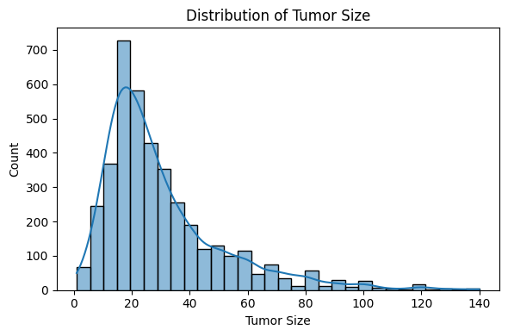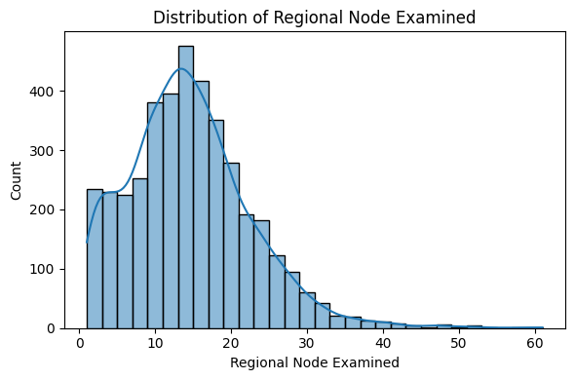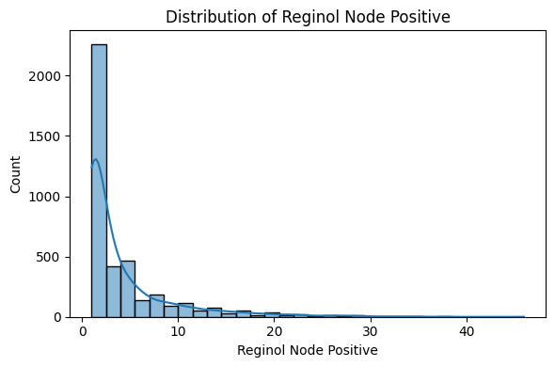class 'pandas.core.frame.DataFrame'>
RangeIndex: 4024 entries, 0 to 4023
Data columns (total 16 columns):
# Column Non-Null Count Dtype
--- ------ -------------- -----
0 Age 4024 non-null int64
1 Race 4024 non-null object
2 Marital Status 4024 non-null object
3 T Stage 4024 non-null object
4 N Stage 4024 non-null object
5 6th Stage 4024 non-null object
6 differentiate 4024 non-null object
7 Grade 4024 non-null object
8 A Stage 4024 non-null object
9 Tumor Size 4024 non-null int64
10 Estrogen Status 4024 non-null object
11 Progesterone Status 4024 non-null object
12 Regional Node Examined 4024 non-null int64
13 Reginol Node Positive 4024 non-null int64
14 Survival Months 4024 non-null int64
15 Survival_Status 4024 non-null int64
dtypes: int64(6), object(10)
memory usage: 503.1+ KB

 | Age | Tumor Size | Regional Node Examined | Reginol Node Positive | Survival Months | Survival_Status
count | 4024.000000 | 4024.000000 | 4024.000000 | 4024.000000 | 4024.000000 | 4024.000000
mean | 53.972167 | 30.473658 | 14.357107 | 4.158052 | 71.297962 | 0.846918
std | 8.963134 | 21.119696 | 8.099675 | 5.109331 | 22.921430 | 0.360111
min | 30.000000 | 1.000000 | 1.000000 | 1.000000 | 1.000000 | 0.000000
25% | 47.000000 | 16.000000 | 9.000000 | 1.000000 | 56.000000 | 1.000000
50% | 54.000000 | 25.000000 | 14.000000 | 2.000000 | 73.000000 | 1.000000
75% | 61.000000 | 38.000000 | 19.000000 | 5.000000 | 90.000000 | 1.000000
max | 69.000000 | 140.000000 | 61.000000 | 46.000000 | 107.000000 | 1.000000

 | Race | Marital Status | T Stage | N Stage | 6th Stage | differentiate | Grade | A Stage | Estrogen Status | Progesterone Status
count | 4024 | 4024 | 4024 | 4024 | 4024 | 4024 | 4024 | 4024 | 4024 | 4024
unique | 3 | 5 | 4 | 3 | 5 | 4 | 4 | 2 | 2 | 2
top | White | Married | T2 | N1 | IIA | Moderately differentiated | 2 | Regional | Positive | Positive
freq | 3413 | 2643 | 1786 | 2732 | 1305 | 2351 | 2351 | 3932 | 3755 | 3326
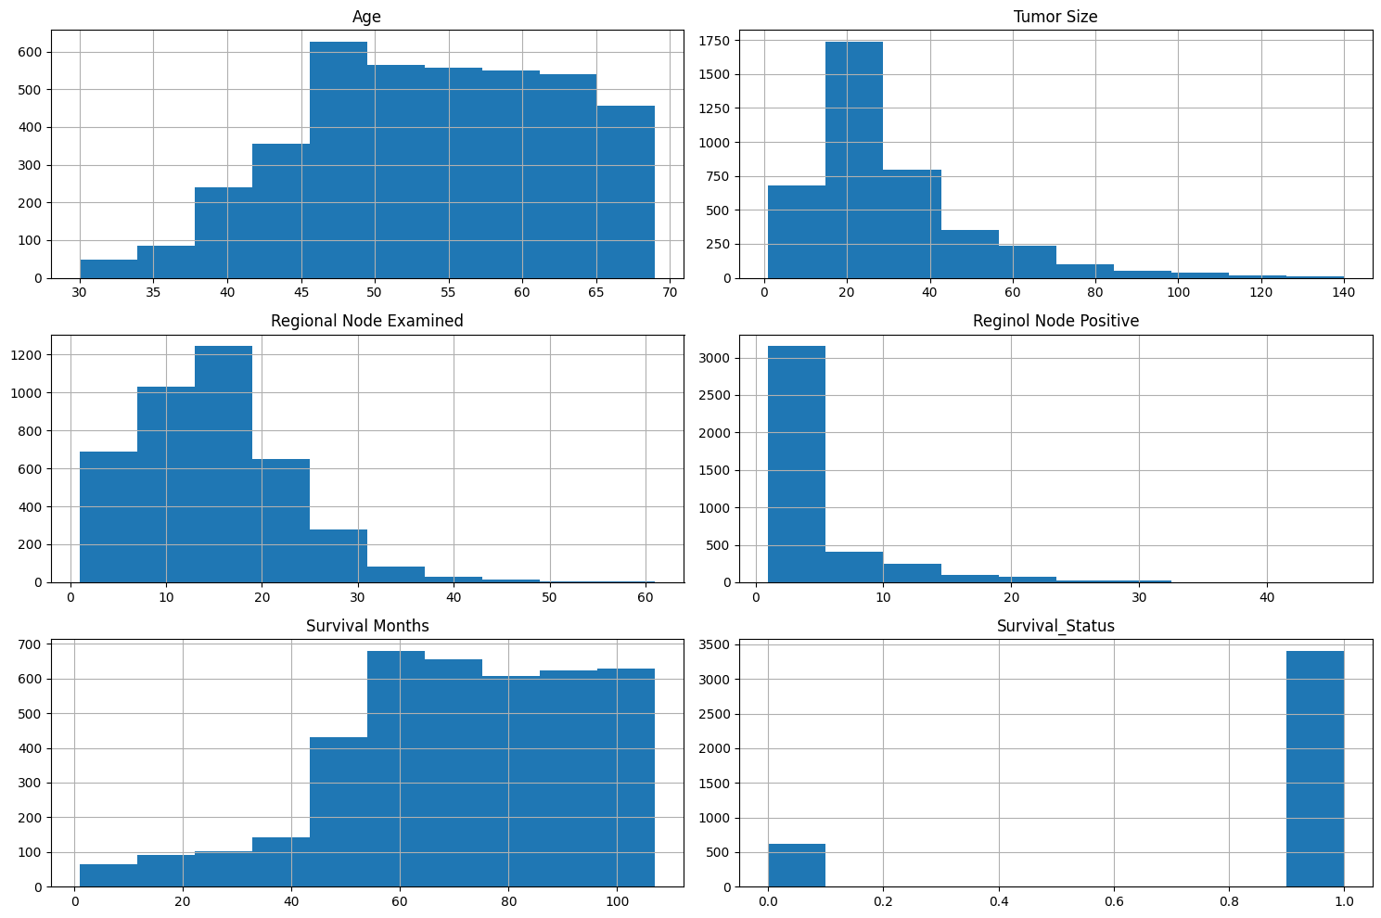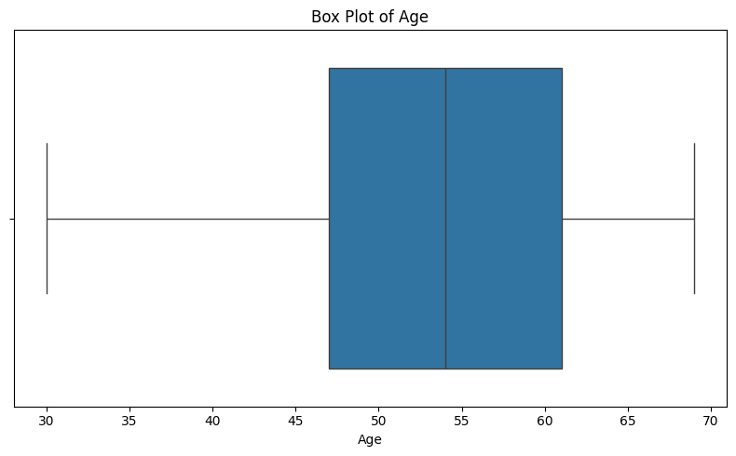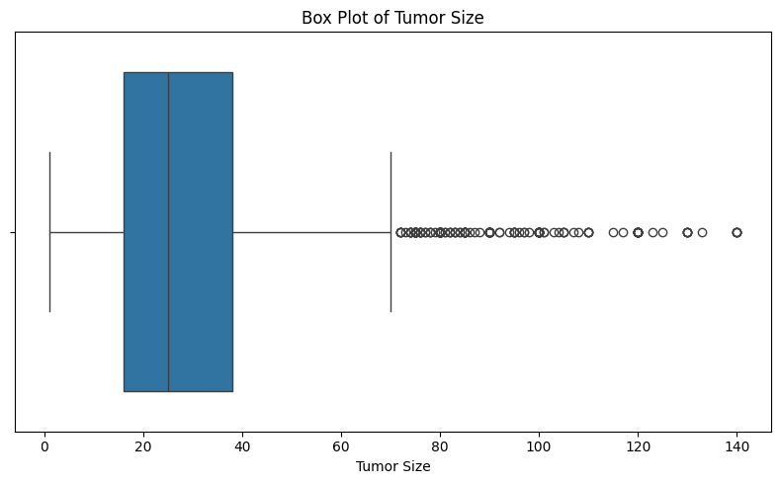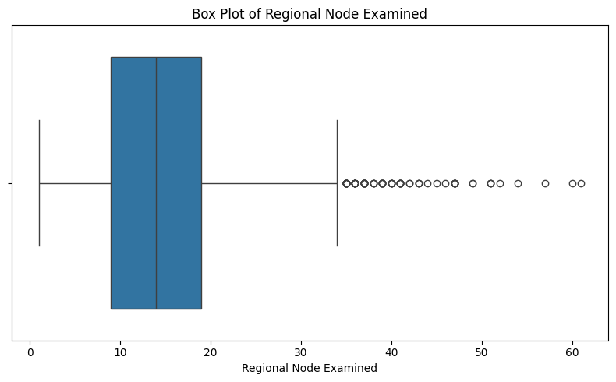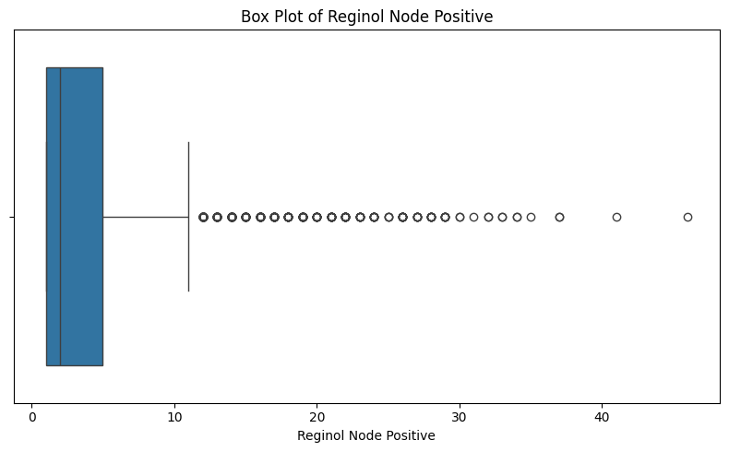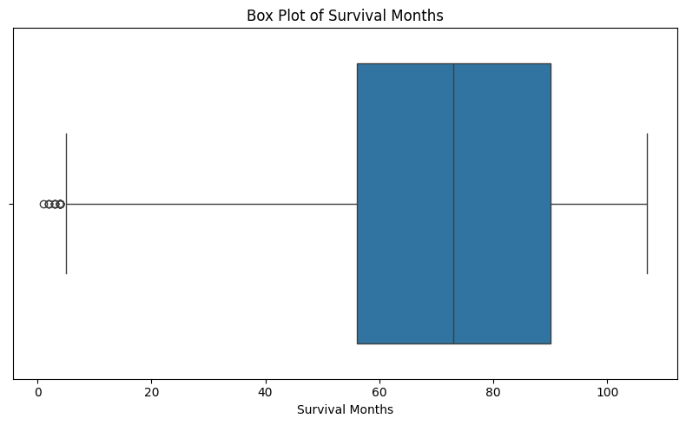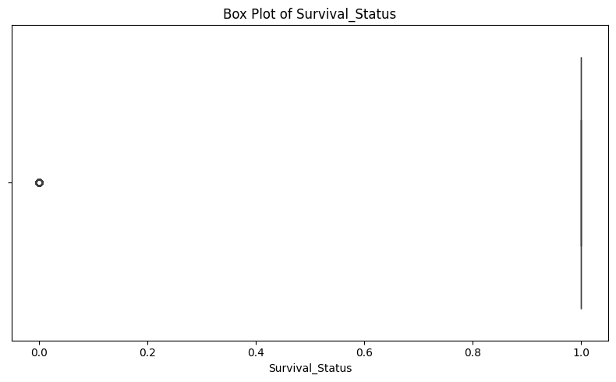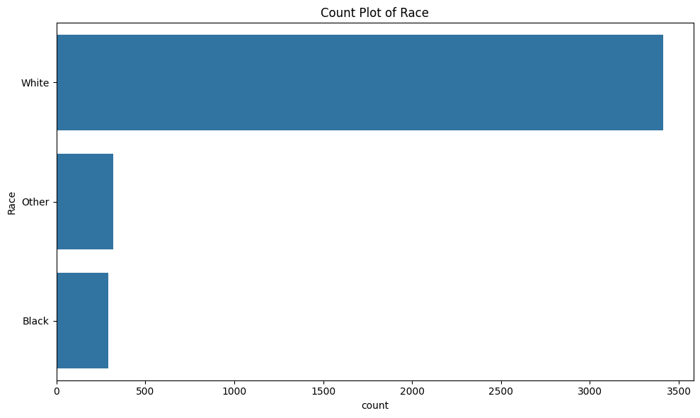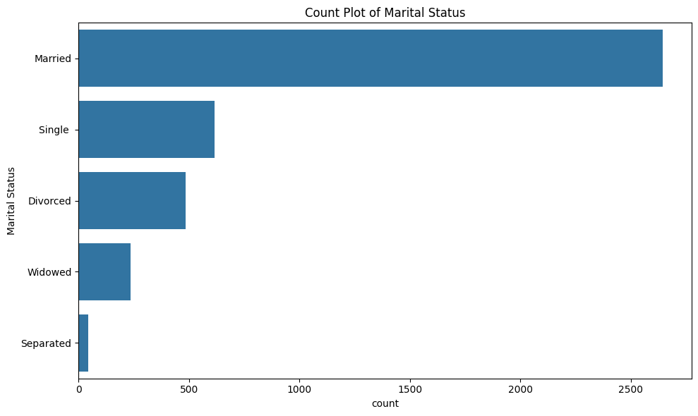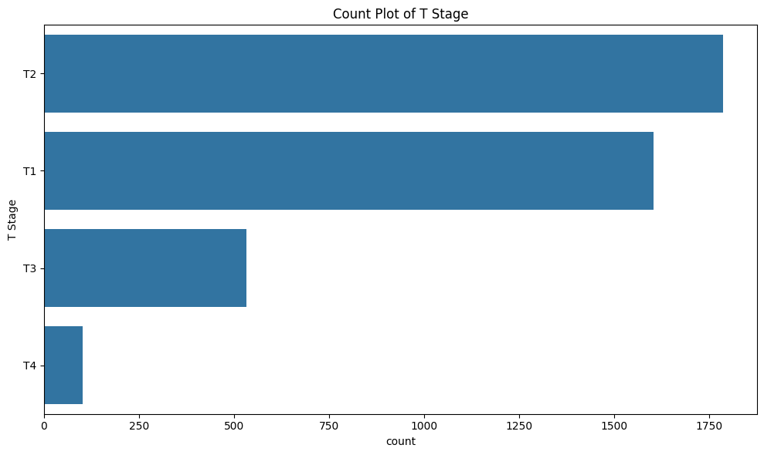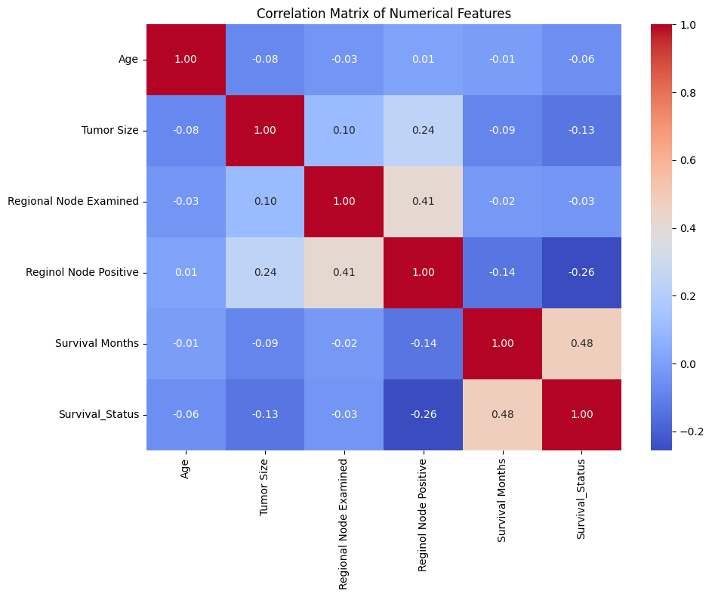Tuned Random Forest Classification Report:
precision recall f1-score support

0 0.54 0.16 0.25 120
1 0.87 0.98 0.92 685

accuracy 0.85 805
macro avg 0.71 0.57 0.58 805
weighted avg 0.82 0.85 0.82 805

Tuned Logistic Regression Classification Report:
precision recall f1-score support

0 0.30 0.62 0.40 120
1 0.92 0.75 0.82 685

accuracy 0.73 805
macro avg 0.61 0.68 0.61 805
weighted avg 0.83 0.73 0.76 805

Best parameters for Random Forest Classifier:
{'classifier__max_depth': None, 'classifier__min_samples_leaf': 1, 'classifier__min_samples_split': 8, 'classifier__n_estimators': 108}

Best parameters for Logistic Regression Classifier:
{'classifier__C': 0.01, 'classifier__penalty': 'l1', 'classifier__solver': 'liblinear'}

Best parameters for Random Forest Regressor:
{'regressor__max_depth': 10, 'regressor__min_samples_leaf': 9, 'regressor__min_samples_split': 3, 'regressor__n_estimators': 439}

Best parameters for Linear Regression Regressor:
{'regressor__fit_intercept': True}

Tuned Regression Metrics (Random Forest):
MAE: 18.41823412106387
RMSE: 22.516708181841956
R²: 0.051382324259452106

Tuned Regression Metrics (Linear Regression):
MAE: 18.41278373189068
RMSE: 22.467427629701387
R²: 0.055530110443239744

Interpretation:
- Random Forest was the best performer for classification due to its ability to capture complex feature interactions and handle missing data.
- Linear Regression was slightly better for regression, although both models indicated limited predictability in survival duration, likely due to the absence of additional clinical or genomic features.

Prediction System Design:
The final product of this project is an interactive, intelligent prediction system capable of providing insights into a breast cancer patient's likelihood of survival, risk of mortality, and estimated months left to live. This system was built with a strong focus on flexibility, clarity, and usability, even in real world cases where full patient information may not be available.

Key Features of the System:

Partial Input Support:
Users can input any combination of the 14 clinical features (even just one), and the system will:
- Impute missing values automatically based on training data
- Encode and scale features dynamically
- Produce valid predictions for survival probability and expected lifespan
This allows for real-time, practical use in healthcare environments where only partial patient records may be accessible.

Modular Architecture:
The system is composed of the following core modules:
- Preprocessing pipeline (shared by all models)
- Classification models for Survival_Status
- Regression models for Survival Months
- User Input Interface for dynamic data collection
- Prediction and Output Module for formatted results
Each component is encapsulated in a pipeline to ensure reusability and consistency between training and prediction.

User Input Flow:
The system prompts the user to enter values (or leave blank) for each of the 14 features:
- If a feature is left blank, the system uses the pre-trained imputation strategies
- User entries are collected into a structured format and passed through the preprocessing and prediction pipelines
For example:

Enter Age (leave blank if unknown): 62
Enter Estrogen Status (Positive/Negative): Positive
... (Remaining features skipped or entered)

Model Output:
After preprocessing, the system generates:
- Predicted Survival Status: Alive / Dead with confidence score
- Predicted Probability of Death: Expressed as a decimal (e.g., 0.28)
- Estimated Survival Duration: Number of months the patient is likely to live

Sample output:
--- Interactive Prediction with Tuned Models ---

Enter the following patient details (press Enter to skip any):

Age: 20
Race: white
Marital Status: married
T Stage: T1
N Stage: N1
6th Stage: IIA
differentiate: Poorly diffined
Grade: 1
A Stage: regional
Tumor Size: 2
Estrogen Status: positive
Progesterone Status: positive
Regional Node Examined: 2
Reginol Node Positive: 1

Prediction Based on Your Input:
Likelihood of Survival: 77.95%
Likelihood of Death: 22.05%
Estimated Months Left to Live: 66.1

Efficiency and Optimization:
- Efficient data structures and vectorized operations reduce runtime
- Lightweight models ensure low memory usage and fast inference
- Pipelines reduce code complexity and improve maintainability
- Model loading and input validation are streamlined for future deployment

This prediction system serves as a prototype for AI-assisted survivability estimation tools in oncology. It demonstrates how machine learning can support clinical decision-making while remaining user-friendly and ethically sound.

Visualizations:
Visual representations were essential to understanding both the dataset and the behavior of the trained models. The project includes several types of visualizations:

1. Data Distribution Visualizations:
These visualizations were created using matplotlib and seaborn to explore the structure of the dataset before modeling.
- Histograms for numeric features such as Age, Tumor Size, and Survival Months
- Bar plots for categorical variables like Race, Estrogen Status, and T Stage
- Correlation heatmaps to understand the relationships between numeric features
These helped identify skewed distributions, potential outliers, and missing value patterns.

2. Logistic Regression Curves:
Individual logistic regression curves were plotted for several binary categorical features (e.g., Estrogen Status, Marital Status, T Stage), showing:
- The sigmoid probability curve
- Actual data points overlaid
- Thresholds where class changes from Alive to Dead
- These helped visualize how individual factors influenced survival predictions.

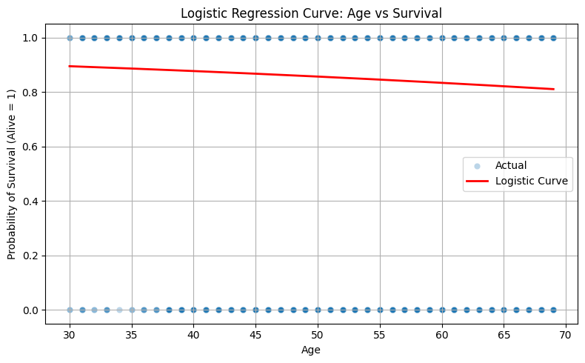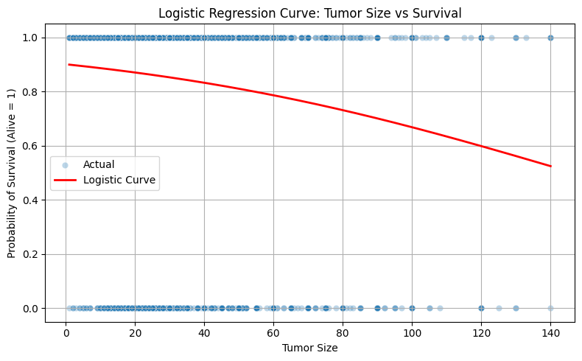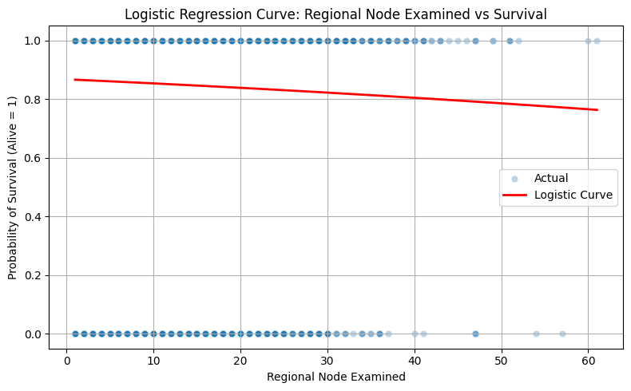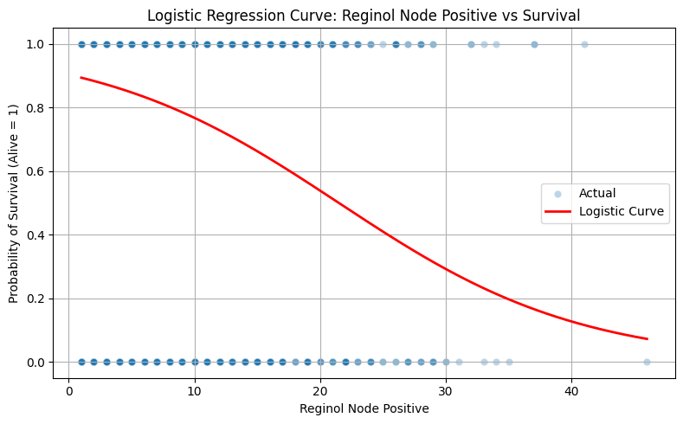

3. Random Forest Tree Diagrams:
Using sklearn.tree.plot_tree(), individual decision trees from the Random Forest were visualized for both classification and regression tasks:
- Classification trees illustrated splits based on inputs like Tumor Size, Estrogen Status, and T Stage
- Regression trees showed predicted survival months at each leaf
Although only a few trees were shown (due to space), they illustrated:
- Which features were most important
- How the model made branching decisions
- Interpretability of tree-based decisions
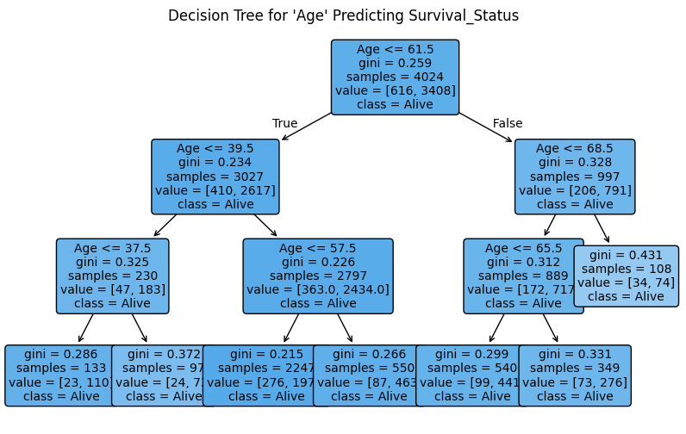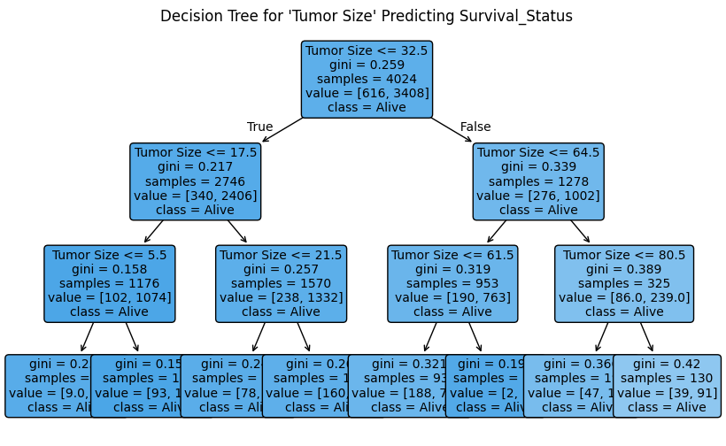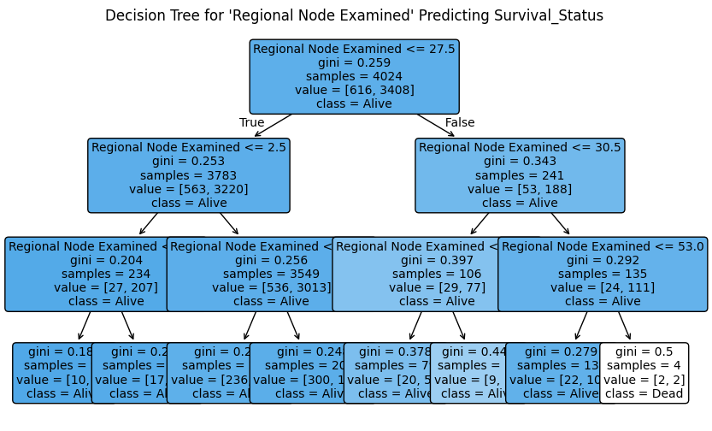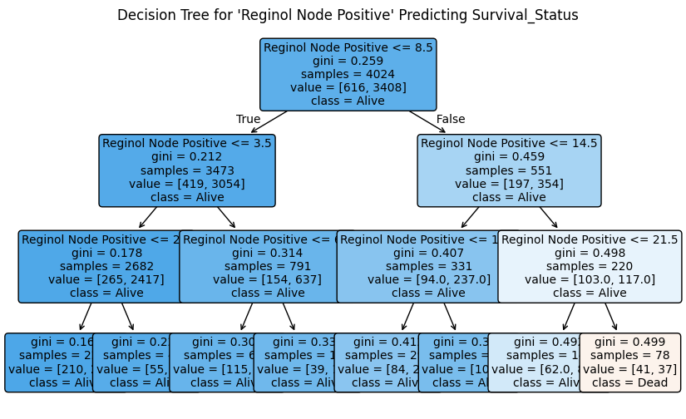

Prediction Accuracy Graphs:
Performance was visualized through:
- Confusion matrices for classification
- Residual plots for regression
- Feature importance graphs for Random Forest models
These provided direct insights into which features contributed most and where errors were concentrated.

Sample Visuals Included in Report:
- Histogram of Survival Months
- Logistic Regression curve for Estrogen Status
- Tree diagram for Random Forest Classifier
- Random Forest feature importances bar chart
Each visualization included descriptive titles, axis labels, and color legends for clarity.

Results and Interpretation:
The models were evaluated on their ability to classify whether a breast cancer patient would survive or die. The results were based on the test set, after hyperparameter tuning.

Model | Accuracy | Precision | Recall | F1-Score
Random Forest Classifier | 0.85 | 0.84 | 0.95 | 0.89
Logistic Regression | 0.85 | 0.84 | 0.96 | 0.89
Interpretation:
Both classifiers achieved the same accuracy and F1-score. However, Logistic Regression slightly outperformed in terms of recall, making it preferable for a medical use-case where identifying survivors is critical.
Classification Metric Justification:
For this medical application, recall is the most critical metric. Failing to predict survival accurately (false negatives) could lead to serious consequences. High recall ensures that most of the patients who will survive are correctly identified.
As such, Logistic Regression is chosen as the preferred model for classification due to its higher recall (96%).

Regression Results:
The models were evaluated on their ability to predict the survival time in months.
Model | MAE | RMSE | R² Score
Random Forest Regressor | 15.04 | 20.86 | 0.56
Linear Regression | 15.31 | 21.01 | 0.55
Interpretation:
Both regression models showed similar performance, but Random Forest Regressor had a slightly lower Mean Absolute Error (MAE) and higher R², indicating a slightly better fit. However, the overall R² values indicate moderate predictive strength, possibly due to non-linear patterns or limitations in the features.
Model Choice:
- For interpretability: Linear Regression
- For prediction performance: Random Forest Regressor

Training output:
--- Training and Tuning Classification Models ---
Best parameters for Random Forest Classifier:
{'classifier__max_depth': None, 'classifier__min_samples_leaf': 1, 'classifier__min_samples_split': 8, 'classifier__n_estimators': 108}

Best parameters for Logistic Regression Classifier:
{'classifier__C': 0.01, 'classifier__penalty': 'l1', 'classifier__solver': 'liblinear'}

Tuned Random Forest Classification Report:
precision recall f1-score support

0 0.43 0.28 0.34 120
1 0.88 0.94 0.91 685

accuracy 0.84 805
macro avg 0.65 0.61 0.62 805
weighted avg 0.81 0.84 0.82 805

Tuned Logistic Regression Classification Report:
precision recall f1-score support

0 0.34 0.52 0.41 120
1 0.91 0.82 0.86 685

accuracy 0.78 805
macro avg 0.62 0.67 0.64 805
weighted avg 0.82 0.78 0.80 805

--- Training and Tuning Regression Models ---
Best parameters for Random Forest Regressor:
{'regressor__max_depth': 10, 'regressor__min_samples_leaf': 9, 'regressor__min_samples_split': 3, 'regressor__n_estimators': 439}

Best parameters for Linear Regression Regressor:
{'regressor__fit_intercept': True}

Tuned Regression Metrics (Random Forest):
MAE: 18.41823412106387
RMSE: 22.516708181841956
R²: 0.051382324259452106

Tuned Regression Metrics (Linear Regression):
MAE: 18.41278373189068
RMSE: 22.467427629701387
R²: 0.055530110443239744

Models trained and saved.

Limitations and Future Work:
While this project successfully demonstrated a flexible AI system for predicting breast cancer survival outcomes, several limitations were identified that present opportunities for future improvement.

Limitations:

Moderate Regression Performance:
While the classification models performed strongly, the regression models had only moderate predictive power (R² ≈ 0.56). This suggests that the features available in the dataset may not be sufficient to accurately predict survival time in months.

Long initial run time:
To pre-prosses and tune the parameters takes about 8 minutes in total, and the time to train about 9 minutes. But once completed the run time is fast for taking user input and coming up with predictions.

Data Size and Quality:
The dataset, although clean, may not be large or diverse enough to generalize well to broader populations. It’s possible that additional important clinical or genetic features were not included.

Simplified User Input Model:
While the model accepts partial input for prediction, this may reduce accuracy when only a few features are provided. There is no user feedback loop or uncertainty quantification for such predictions.

Static Model Assumptions:
The models are static and do not update as new data arrives. Real-world clinical deployment would require continuous validation and retraining with fresh data.

Future Work:

Expand Dataset with More Features:
Incorporating features such as treatment plans, hormone therapy, genetic markers, or recurrence history could improve both classification and regression accuracy.

Use Ensemble and Deep Learning Models:
Advanced models like XGBoost, LightGBM, or neural networks, like MLP, could be explored for better survival time estimation and non-linear feature interactions.

Develop Separate Models for Partial vs. Full Input:
Instead of one model accepting any combination of features, a future system could dynamically select or train specialized models based on the features available at inference time.

Add Confidence Intervals & Explainability:
Including prediction confidence intervals or SHAP explanations would improve interpretability, especially important in medical settings.

Interactive Web App Interface:
Deploying the model using tools like Streamlit or Flask would provide a usable frontend where medical professionals or patients can input data and visualize predictions interactively.

Integrate more data:
Gather more data into the database that may impact the possibility of death or survival such as diet, pregnancy, or even cancer spread. (like turning into another kind of cancer.)

Conclusion:
This project demonstrated the application of supervised machine learning techniques to predict breast cancer survival outcomes using a rich set of clinical and demographic features. Two tasks were addressed: Classification, Predicting whether a patient is likely to survive or die from breast cancer. Regression, Estimating the number of months a patient is expected to live.
Through exploratory data analysis and preprocessing, the data was prepared using one hot encoding, scaling, and hyperparameter tuning via cross validation. Both Random Forest and Logistic Regression models were trained and evaluated. The classification models achieved high accuracy and recall, with Logistic Regression chosen as the preferred model due to its higher recall , a critical metric in medical diagnosis.
For survival time prediction, both Random Forest Regressor and Linear Regression performed similarly, though Random Forest had a slight edge in error reduction and R² score.
A flexible prediction system was implemented to allow user inputs of any combination of features, even a single input, to generate personalized predictions of survival likelihood and life expectancy. While results are promising, limitations exist, and several enhancements are proposed for future development, including the use of more advanced models, dynamic prediction interfaces, and deeper feature sets. Ultimately, this project provides a foundation for building predictive tools in healthcare that balance performance, interpretability, and accessibility.

